DIS-Ghost Dance Doll

# **This is a Lakota Sioux Native American Ghost Dance double doll,** "A-NOG-I-TE"

**Ghost Dance Double Doll hand made by the Lakota Sioux (circa 1890-1910).** These dolls were ceremonial in nature and the bead work is on both sides but done in different colors. **The piece features a unique and rare design of being two unique dolls having different faces and outfits on both sides. One side is sad because the people and buffalo are being killed, while the other side is happy because the belief in the Messiah will bring back the buffalo and the dead.** FULL BRAIN TANNED DEERSKIN, PAINTED ON BOTH SIDES, **with numerous Ghost Dance figures, red Hudson Bay white heart Trade Beads, and human hair. The piece was collected from Chamberlain South Dakota. Measures 12" long. This is both trade cotton and sinew sewn. The piece shows human hair, trade seed bead facial features, trade bead necklace, and abalone earrings. The doll is hand mineral painted with both sides showing a unique design. Very rare and in good condition**

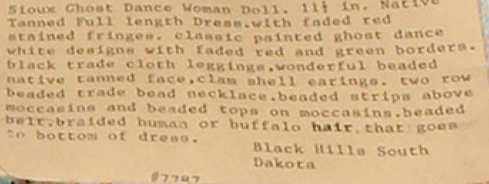

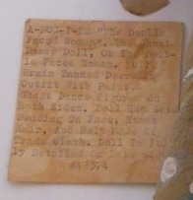

Ghost Dance Doll, *A-nog-i-te*, “Double-faced woman,” Lakota Sioux Indian Doll from Chamberlain, South Dakota. *A-nog-i-te* is the wife of *Tate* (Wind) and daughter of *Skan* (Sky). Her name reflects her two faces; one beautiful, the other ugly, a punishment for her attempt to seduce *Wi* (Sun). In other Lakota tales she is the bringer of "quilling," the craft of sorting and dyeing porcupine quills. Here she wears the clothing of the Ghost dance. In this guise the “ugly” visage reflects the duality of the Lakota being saddened of the period before the appearance of the Messiah when the white man destroyed the buffalo and the ancient lifeways. The other face is gladdened by the period after the appearance of the Messiah when the buffalo and the ancient lifeways were restored. Ghost Dance dresses and shirts were promoted by the Lakota as embodying their personal apocalyptic dream visions incorporating symbols of the morning four-pointed star, the evening polaris five-pointed star, the crescent moon and the circular sun that would make the wearer a harbinger of the new earth and impervious to the destruction by the white man. These dolls were ceremonial in nature and used to invoke the fruit of these visions. While the bead work is identical on both sides it is done in different colors. The full brain-tanned dress is hand painted with earth paints with some flaking. Body has trade cloth leggings. Upper body is canvass. , Painted on both sides, Seed bead face with horse hair, hair. Has beaded moccasins. Doll necklaces has blue white hart beads and ear pieces are pearl shell buttons. Approx. 12" tall x 7" wide hand to hand. It is made of native-tanned hide paint on old white muslin body. It has red trade cloth leggings, seed beaded face with beaded necklace. Trade beaded belt, conch shell earrings and conch shell buttons on the leggings and last seed beaded moccasins.